Tribhuvan University
Bachelor of Computer Application (BCA)
Multimedia System
(CACS457)
Lab Report
Submitted by: Rojan Chandra Poudel

Lab No: 01 Date:
1. Title of Experiment
Create a multimedia presentation on any educational topic using text, images, audio, video, transitions, and animation.
2. Objective
To design a multimedia presentation that integrates multiple media types (text, image, audio, video) along with slide transitions and animation effects to communicate an educational topic effectively.
3. Required Software/Hardware
- A computer running Windows / Linux / macOS
- Microsoft PowerPoint / Google Slides / Canva (presentation authoring tool)
- Sample images relevant to the chosen topic
- A short audio clip (narration or background music) and a short video clip
4. Theory
A multimedia presentation combines several media elements -- text, still images, audio, video, and animated effects -- into a single, sequential, interactive package, usually organized as slides. Combining media types improves engagement and helps convey information that text alone cannot express as clearly.
Slide transitions control how one slide changes to the next (e.g. fade, wipe, push), while animations control how individual objects on a single slide appear, move, or disappear (e.g. entrance, emphasis, exit effects). Together they add pacing and visual interest without overwhelming the core content.
5. Procedure/Algorithm
- Choose an educational topic (e.g. 'Introduction to Artificial Intelligence' or 'The Water Cycle').
- Create an outline of slides covering the introduction, main content, and conclusion.
- Insert relevant text and images on each slide to support the topic.
- Insert an audio clip (narration or background music) on the appropriate slide(s).
- Insert a short video clip that supports the topic.
- Apply a slide transition effect between slides.
- Apply animation effects to key text/image objects (e.g. entrance and emphasis).
- Preview the full presentation and save/export the final file.
6. Implementation/Steps
- Open PowerPoint (or Google Slides/Canva) and create a new blank presentation.
- Use Insert > Text Box for headings and bullet content on each slide.
- Use Insert > Pictures to add relevant images to illustrate each point.
- Use Insert > Audio to embed the narration/background music clip; set it to play automatically or on click as needed.
- Use Insert > Video to embed the chosen video clip on its slide.
- Go to the Transitions tab, select a transition style, and click 'Apply to All' or apply per-slide.
- Go to the Animations tab, select each object, and apply an entrance/emphasis animation; use Animation Pane to set the order and timing.
- Run Slide Show > From Beginning to preview, then save the file (File > Save As) as .pptx.
7. Output/Screenshot
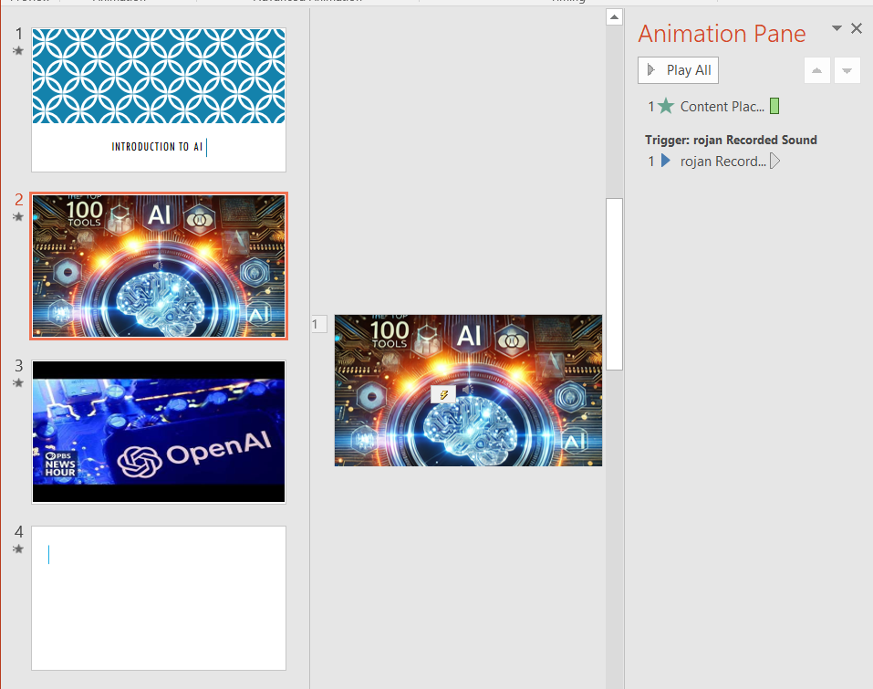
Figure 1: use of power point
8. Result
A multimedia presentation combining text, images, audio, video, transitions, and animation was successfully created, demonstrating how multiple media types can be integrated into a single cohesive presentation.

Lab No: 02 Date:
1. Title of Experiment
Record a 30–60 second digital audio clip, edit it by removing unwanted portions and noise, and save it in WAV and MP3 formats.
2. Objective
To record a short digital audio clip, clean it up by trimming unwanted portions and reducing background noise, and export the result in both WAV and MP3 formats.
3. Required Software/Hardware
- A computer running Windows / Linux / macOS
- Audacity (free digital audio editor)
- A microphone (built-in or external)
4. Theory
Digital audio recording captures sound waves by sampling amplitude at regular time intervals (the sampling rate) and storing each sample using a fixed number of bits (the bit depth). Real-world recordings often contain unwanted noise (hiss, hum, background sound) that can be reduced using noise-reduction algorithms, which typically use a 'noise profile' taken from a silent section of the recording to identify and subtract the noise pattern.
WAV is an uncompressed (or losslessly compressed) audio container that preserves full audio quality but produces larger files, while MP3 uses lossy compression to shrink file size significantly by discarding audio detail that is less perceptible to the human ear.
5. Procedure/Algorithm
- Open Audacity and select the correct microphone as the recording input.
- Record a 30-60 second audio clip (e.g. speaking a short paragraph).
- Use Select and Delete/Trim to remove unwanted portions at the start/end or within the clip.
- Select a short section containing only background noise, then use Effect > Noise Reduction to capture a noise profile.
- Apply the noise reduction effect to the whole track to reduce background noise.
- Export the cleaned audio as a WAV file (File > Export > Export as WAV).
- Export the same cleaned audio as an MP3 file (File > Export > Export as MP3).
- Compare the file sizes of the WAV and MP3 versions.
6. Implementation/Steps
- Launch Audacity, click the red Record button, speak/record for 30-60 seconds, then click Stop.
- Use the Selection Tool to highlight unwanted silence or mistakes, then press Delete (or Ctrl+K) to remove them.
- Select a 1-2 second region that is pure background noise (no speech), go to Effect > Noise Reduction, click 'Get Noise Profile'.
- Select the entire track (Ctrl+A), reopen Effect > Noise Reduction, and click OK to apply the reduction.
- Go to File > Export > Export as WAV, choose a filename, and save.
- Go to File > Export > Export as MP3 (installing the LAME encoder if prompted the first time), choose a filename, and save.
- Right-click each exported file in File Explorer/Finder and check Properties/Get Info to compare file sizes.
7. Output/Screenshot
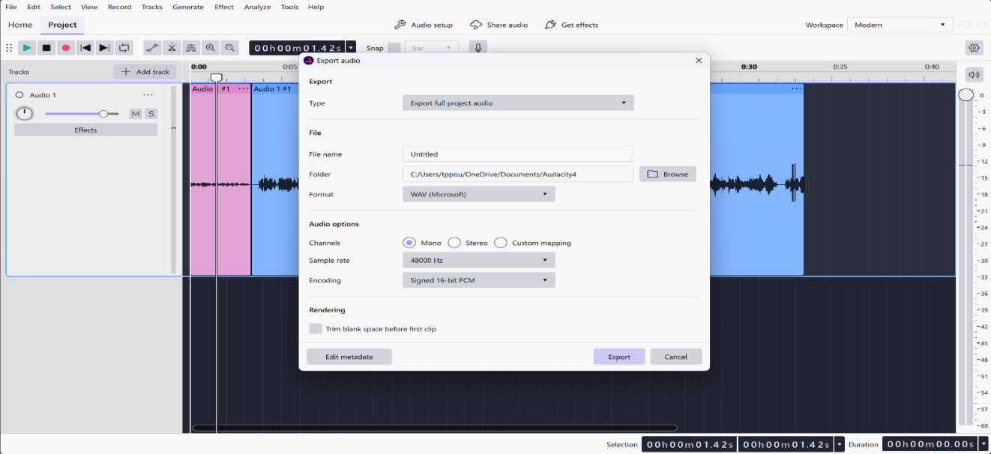
Figure 2 : Export as WAV
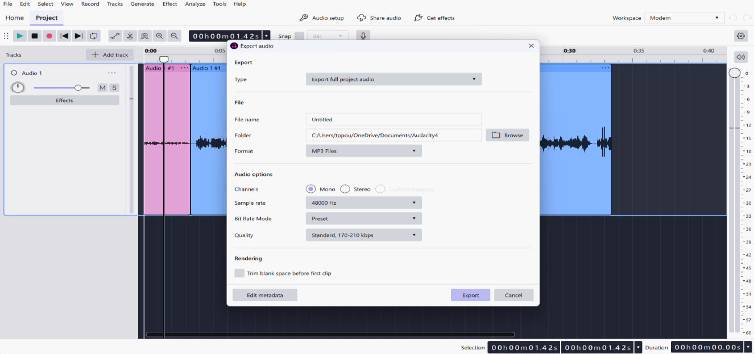
Figure 3: Export as MP3
8. Result
A 30-60 second audio clip was successfully recorded, trimmed, and cleaned of background noise, then exported in both WAV and MP3 formats -- with the MP3 file noticeably smaller in size due to lossy compression, while the WAV file retained full audio fidelity.

Lab No: 03 Date:
1. Title of Experiment
Demonstrate the effect of sampling rate and bit depth on digital audio. Compare the file sizes and audio quality at different settings.
2. Objective
To export the same audio recording at different sampling rates and bit depths, and compare the resulting file sizes and perceived audio quality.
3. Required Software/Hardware
- A computer running Windows / Linux / macOS
- Audacity (free digital audio editor)
- A short pre-recorded or newly recorded audio clip
4. Theory
The sampling rate is the number of amplitude samples taken per second (measured in Hz), and determines the highest frequency that can be accurately represented (per the Nyquist theorem, the sampling rate must be at least twice the highest frequency of interest). Common rates are 44.1 kHz (CD quality), 22.05 kHz, and 8 kHz (telephone quality).
The bit depth is the number of bits used to represent each sample's amplitude, and determines the dynamic range and quantization noise -- 16-bit audio (CD quality) has far less quantization noise than 8-bit audio. Lower sampling rate and bit depth both reduce file size but also reduce audio fidelity, especially noticeable as muffled high frequencies (low sample rate) or added hiss/graininess (low bit depth).
5. Procedure/Algorithm
- Open (or record) an audio clip in Audacity.
- Export the same clip at a high sampling rate and bit depth (e.g. 44100 Hz, 16-bit).
- Export the same clip at a reduced sampling rate (e.g. 22050 Hz or 8000 Hz), keeping bit depth the same.
- Export the same clip at a reduced bit depth (e.g. 8-bit), keeping sampling rate the same.
- Note the file size of each exported version.
- Play back each version and note the audible difference in quality.
6. Implementation/Steps
- In Audacity, click the sample rate selector at the bottom-left of the window (or use Tracks > Resample) to set the project rate to 44100 Hz, then export as WAV -- call this version A.
- Change the project rate to 22050 Hz (or 8000 Hz), export as WAV -- version B.
- With the rate back at 44100 Hz, go to File > Export > choose a WAV subtype with 8-bit PCM (via 'Other uncompressed files' > Header: WAV, Encoding: Unsigned 8-bit PCM), export -- version C.
- Check each file's size via File Explorer/Finder Properties, and record the values in a comparison table.
- Play back versions A, B, and C and note differences (muffled high end for low sample rate; hiss/graininess for low bit depth).
7. Output/Screenshot
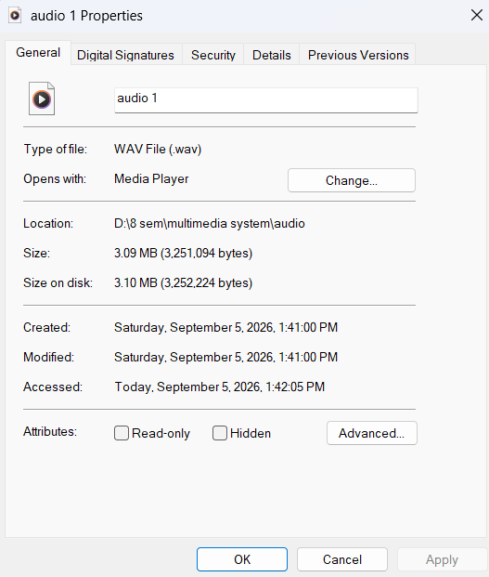
Figure 4: 44100 Hz
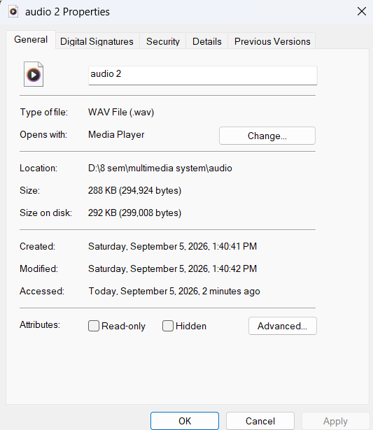
Figure 5: Rate to 8000 Hz Unsigned 8-bit PCM

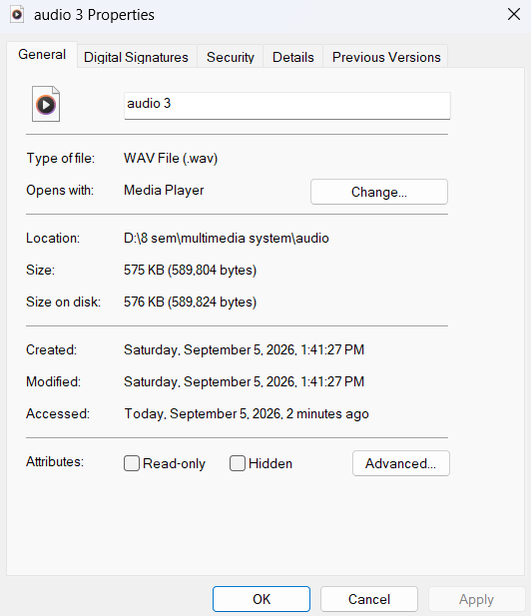
Figure 6: Rate to 8000 Hz
8. Result
Reducing the sampling rate and bit depth both produced noticeably smaller audio files, but at the cost of audio quality -- the lower sampling rate lost high-frequency detail (muffled sound), and the lower bit depth introduced audible quantization noise (hiss/graininess), confirming the trade-off between file size and fidelity.

Lab No: 04 Date:
1. Title of Experiment
Create a simple MIDI music sequence using a MIDI-compatible application. Change instruments, tempo, and notes and compare MIDI with digital audio.
2. Objective
To compose a short MIDI sequence using a MIDI sequencer application, experiment with changing instruments, tempo, and notes, and compare the characteristics of MIDI with recorded digital audio.
3. Required Software/Hardware
- A computer running Windows / Linux / macOS
- A MIDI sequencer application (e.g. MuseScore, Anvil Studio, GarageBand, or an online sequencer such as Online Sequencer)
4. Theory
MIDI (Musical Instrument Digital Interface) does not store actual sound; instead it stores a sequence of instructions/events (which note, how loud, which instrument, when to start/stop) that a synthesizer or sound module interprets to produce audio at playback time. This makes MIDI files extremely small compared to digital audio, and fully editable (notes, tempo, instrument can all be changed after the fact).
Digital audio (e.g. WAV/MP3), in contrast, stores the actual sampled waveform of a specific performance -- it sounds identical every time but cannot be easily re-arranged (e.g. changing 'instrument' after recording is not possible without re-recording).
5. Procedure/Algorithm
- Open a MIDI sequencer application and create a new project.
- Enter a short sequence of notes (a simple melody) on a chosen track/instrument.
- Play back the sequence and confirm it sounds correct.
- Change the assigned instrument (e.g. from Piano to Violin) and note the audible difference using the same notes.
- Change the tempo (beats per minute) and note the effect on playback speed.
- Export/save the MIDI file, and separately render or export an audio version (WAV/MP3) of the same sequence.
- Compare the MIDI file size with the exported audio file size.
6. Implementation/Steps
- Open the sequencer and create a new empty project/track.
- Click on the piano-roll/staff editor and enter 8-16 notes to form a short melody.
- Select the track's instrument dropdown and choose an instrument (e.g. Acoustic Grand Piano); play back to confirm.
- Change the instrument to a different one (e.g. Violin or Flute) and play back the same notes again.
- Locate the tempo control (BPM) and change it from the default (e.g. 120 BPM to 80 BPM or 160 BPM); play back and note the speed change.
- Save/export the project as a .mid file.
- Use the application's 'Export Audio' / 'Render to Audio' feature (or record the MIDI playback) to also save a .wav or .mp3 version.
- Compare file sizes of the .mid file versus the exported audio file in File Explorer/Finder.
7. Output/Screenshot

8. Result
A short MIDI sequence was created and successfully modified by changing its instrument and tempo without needing to re-record anything. The MIDI file was dramatically smaller than the exported digital audio version, confirming that MIDI stores instructions rather than actual sound.

Lab No: 05 Date:
1. Title of Experiment
Create and edit a digital image using an image-editing tool. Perform cropping, resizing, brightness/contrast adjustment, and text insertion.
2. Objective
To use a raster image-editing tool to perform common editing operations -- cropping, resizing, brightness/contrast adjustment, and text insertion -- on a digital image.
3. Required Software/Hardware
- A computer running Windows / Linux / macOS
- GIMP (free) or Adobe Photoshop
- A sample photo/image
4. Theory
Raster image editing manipulates images that are represented as a grid of pixels, each holding color information. Common operations include cropping (removing unwanted areas by selecting a rectangular region to keep), resizing/scaling (changing the pixel dimensions of the image, which can affect quality if enlarged), brightness/contrast adjustment (altering pixel intensity values to make an image lighter/darker or increase/decrease the difference between light and dark areas), and adding text as an overlay layer.
5. Procedure/Algorithm
- Open the sample image in the image-editing tool.
- Use the Crop tool to select and remove unwanted areas of the image.
- Use the Scale/Resize tool to change the image's dimensions.
- Use the Brightness-Contrast tool to adjust the image's tone.
- Add a text layer with a caption or title over the image.
- Flatten and export/save the final edited image.
6. Implementation/Steps
- Open GIMP/Photoshop and load the sample image (File > Open).
- Select the Crop tool, drag a rectangle around the desired area, and press Enter to apply the crop.
- Go to Image > Scale Image (GIMP) or Image > Image Size (Photoshop), enter new width/height, and apply.
- Go to Colors > Brightness-Contrast (GIMP) or Image > Adjustments > Brightness/Contrast (Photoshop), move the sliders, and apply.
- Select the Text tool, click on the image, type a caption, and position/style it as needed.
- Flatten the image (Image > Flatten Image) and export it (File > Export As / Save As) as a JPEG or PNG.
7. Output/Screenshot

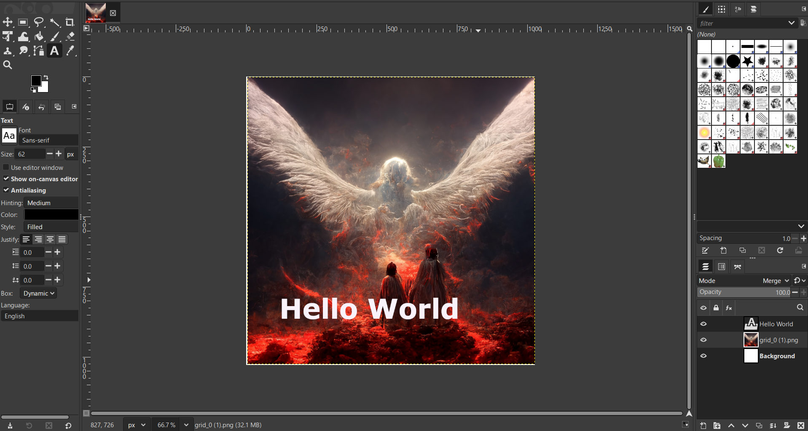
8. Result
The sample image was successfully cropped, resized, adjusted for brightness/contrast, and annotated with inserted text, demonstrating the core raster image-editing workflow.

Lab No: 06 Date:
1. Title of Experiment
Create the same graphic using raster and vector graphics and compare their quality, scalability, and file size.
2. Objective
To create an identical simple graphic (e.g. a logo or shape) using both a raster tool and a vector tool, then compare their image quality at different zoom levels, scalability, and file size.
3. Required Software/Hardware
- A computer running Windows / Linux / macOS
- GIMP (raster editor)
- Inkscape (vector editor)
4. Theory
Raster graphics represent images as a fixed grid of pixels; enlarging a raster image beyond its original resolution causes visible pixelation/blurring because no new detail is generated. Vector graphics represent images as mathematical descriptions of shapes (points, lines, curves, and fills), which can be scaled to any size without any loss of quality because the shape is recalculated at render time rather than stored as fixed pixels.
Vector files are often smaller for simple geometric graphics (logos, icons, text) since they store formulas rather than per-pixel data, while raster files scale in size roughly with the number of pixels and color depth. Raster is generally better suited for photographs and complex continuous-tone images, while vector is better suited for logos, icons, and illustrations that need to be resized often.
5. Procedure/Algorithm
- Design a simple graphic (e.g. a star, a simple logo) in GIMP using raster drawing tools.
- Design the same graphic in Inkscape using vector shapes/paths.
- Export both graphics at a small size and note their file sizes.
- Enlarge (zoom in or scale up) both graphics significantly and observe the visual quality.
- Compare quality, scalability, and file size between the two versions.
6. Implementation/Steps
- In GIMP, create a new image and use the shape/paint tools to draw the chosen graphic; export it as a PNG.
- In Inkscape, use the shape tools (star, rectangle, bezier/pen tool) to draw the same graphic; export it as both SVG (vector) and PNG (rasterized) at the same nominal size.
- Note the file size of the raster PNG versus the vector SVG file.
- Zoom into both images at 400-500% (or scale the canvas up) and take a screenshot of each, comparing edge sharpness.
- Summarize the observed differences in a short comparison table (quality at scale, scalability, file size).
7. Output/Screenshot

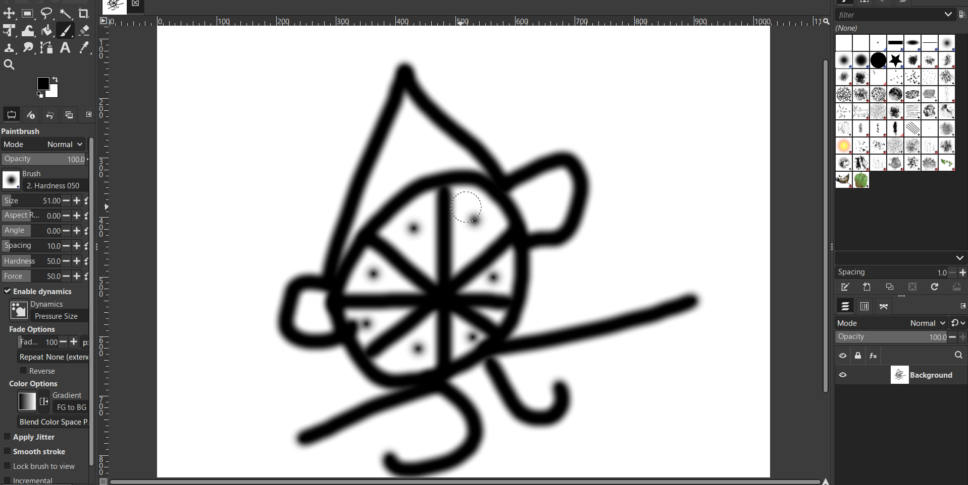
Figure 7: GImp PNG
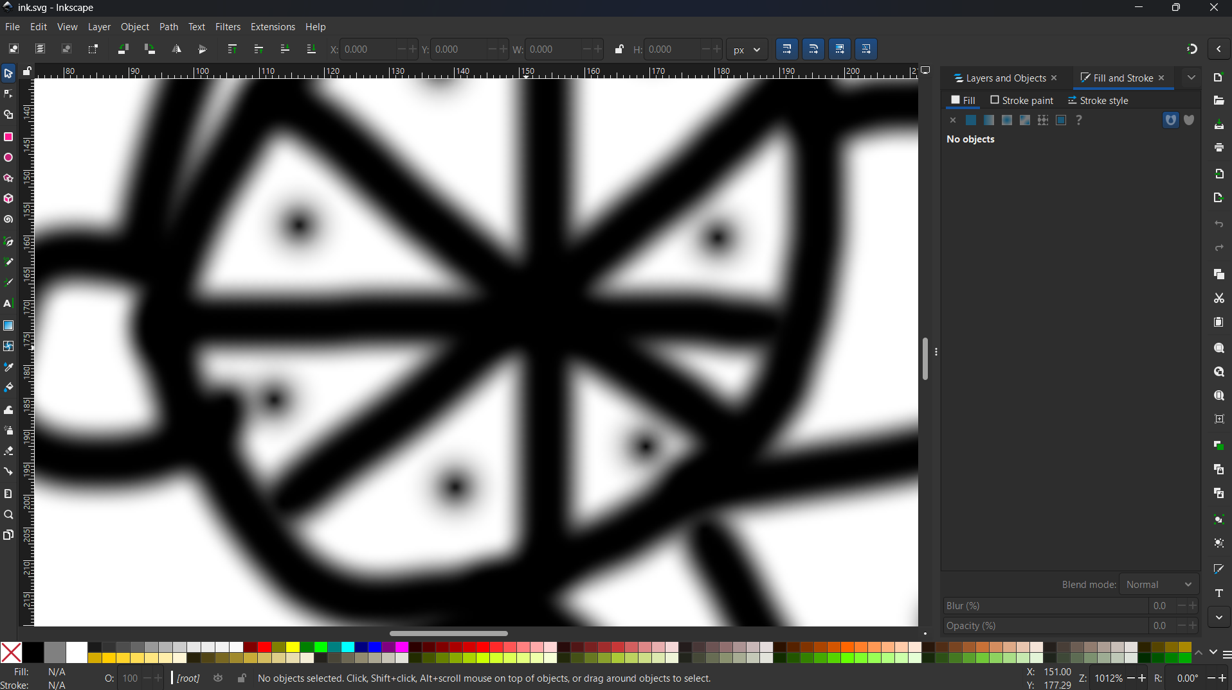
Figure 8 : Inkscape SVG
8. Result
The vector version of the graphic remained perfectly sharp at any zoom level, while the raster version became visibly pixelated when enlarged. The vector (SVG) file was also smaller than the raster (PNG) file for this simple graphic, confirming vector graphics are better suited for scalable artwork such as logos and icons.

Lab No: 07 Date:
1. Title of Experiment
Convert an image into JPEG, PNG, GIF, and BMP formats. Compare their file sizes and explain the differences.
2. Objective
To export/convert the same source image into JPEG, PNG, GIF, and BMP formats, and compare their resulting file sizes and characteristics.
3. Required Software/Hardware
- A computer running Windows / Linux / macOS
- GIMP or any image editor/viewer capable of 'Export As' / 'Save As' to multiple formats
- A sample image
4. Theory
BMP is an uncompressed (or minimally compressed) raster format that stores every pixel's color value directly, producing large files but perfect fidelity. PNG uses lossless compression (DEFLATE), reducing file size without losing any image data, and supports transparency. JPEG uses lossy compression based on the Discrete Cosine Transform (DCT), achieving much smaller files by discarding image detail that is less perceptible to the eye, at the cost of some quality loss, and does not support transparency. GIF uses a limited 256-color indexed palette with lossless LZW compression, making it efficient for simple graphics/animations but poor for photographic images with many colors.
5. Procedure/Algorithm
- Open the sample image in the image editor.
- Export/save a copy in BMP format.
- Export/save a copy in PNG format.
- Export/save a copy in JPEG format.
- Export/save a copy in GIF format.
- Compare the file size of all four versions and note visual differences (especially for GIF, which may show color banding).
6. Implementation/Steps
- In GIMP, open the sample image (File > Open).
- Use File > Export As, and change the filename extension to .bmp, then export.
- Repeat File > Export As for .png, .jpg, and .gif, exporting a copy in each format.
- Right-click each exported file in File Explorer/Finder and check its size under Properties/Get Info.
- Zoom into each saved version, especially the GIF, to spot any color banding or quality loss compared to the original.
7. Output/Screenshot
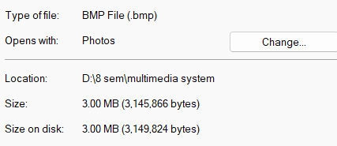
Figure 9: export as BMP
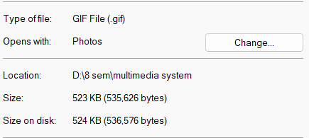
Figure 10 : export as GIF
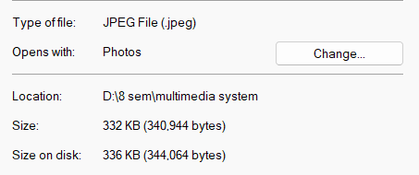
Figure 11: export as JPEG
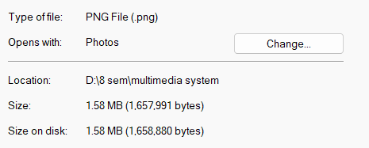
Figure 12: export as PNG
8. Result
The BMP file was the largest (uncompressed), PNG was smaller due to lossless compression, JPEG was the smallest due to lossy compression (with a slight quality trade-off), and GIF produced a small file but showed visible color-banding due to its 256-color limitation -- confirming each format's compression trade-offs.

Lab No: 08 Date:
1. Title of Experiment
Perform lossless and lossy image compression on a sample image. Calculate the compression ratio and compare the resulting image quality.
2. Objective
To compress a sample image using both a lossless method (PNG) and a lossy method (JPEG at varying quality levels), calculate the compression ratio for each, and compare the resulting image quality.
3. Required Software/Hardware
- A computer running Windows / Linux / macOS
- GIMP or any image editor with adjustable JPEG export quality
- A sample uncompressed image (e.g. BMP)
4. Theory
Compression ratio is calculated as: Compression Ratio = Original File Size / Compressed File Size. A higher ratio means more size reduction. Lossless compression (e.g. PNG) reduces file size while allowing the original image to be reconstructed exactly, typically achieving modest compression ratios. Lossy compression (e.g. JPEG) can achieve much higher compression ratios by permanently discarding some image detail, with higher compression (lower quality setting) producing smaller files but more visible artifacts (blockiness, blurring) -- especially around sharp edges.
5. Procedure/Algorithm
- Start with an uncompressed sample image (e.g. BMP) and note its file size.
- Save a lossless PNG version and note its file size.
- Save a lossy JPEG version at high quality (e.g. 90%) and note its file size.
- Save a lossy JPEG version at low quality (e.g. 30%) and note its file size.
- Calculate the compression ratio for each compressed version relative to the original.
- Visually compare quality between the original, high-quality JPEG, and low-quality JPEG (zoom into edges/details).
6. Implementation/Steps
- In GIMP, open the original BMP image and note its size in File Explorer/Finder.
- Use File > Export As, save as .png, and note the resulting file size.
- Use File > Export As, save as .jpg; in the JPEG export dialog set quality to ~90 and export; note the file size.
- Repeat the JPEG export with quality set to ~30; note the file size.
- Compute compression ratio = original size / compressed size for the PNG, the 90%-quality JPEG, and the 30%-quality JPEG.
- Zoom into a detailed area (e.g. text or a sharp edge) in each version and compare visible quality loss/artifacts.
7. Output/Screenshot
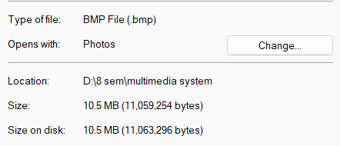
Figure 13: BMP original picture
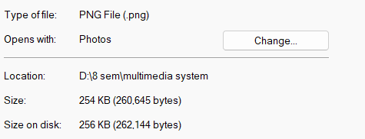
Figure 14: High quality PNG
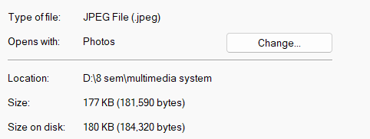
Figure 15: High quality JPEG
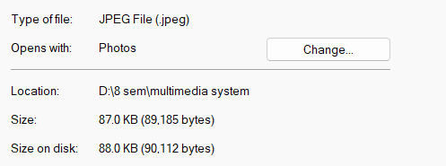
Figure 16 : low Quality JPEG
8. Result
The PNG (lossless) version achieved a modest compression ratio with no visible quality loss, while the JPEG (lossy) versions achieved much higher compression ratios -- the low-quality JPEG being the smallest but showing clearly visible blocky artifacts, confirming the expected trade-off between compression ratio and image quality.

Lab No: 09 Date:
1. Title of Experiment
Create a short digital video by combining video clips, images, text, background music, transitions, and voice narration. [Must be related to BCA or Some AI]
2. Objective
To produce a short digital video, related to BCA or Artificial Intelligence, that combines multiple video clips, images, text overlays, background music, transitions, and voice narration into a single cohesive video.
3. Required Software/Hardware
- A computer running Windows / Linux / macOS
- A video editing tool (e.g. Shotcut, DaVinci Resolve, CapCut, or Windows/Clipchamp Video Editor)
- A few short video clips and/or images related to the chosen topic (e.g. 'A Day in the Life of a BCA Student' or 'What is Artificial Intelligence?')
- Background music track and a microphone for narration
4. Theory
Digital video editing combines multiple media sources (video clips, still images, audio tracks, text overlays) on a multi-track timeline, where the vertical position of a clip determines layering (e.g. video below, title text above) and the horizontal position determines timing. Transitions (e.g. cross-fade, wipe) smooth the change between adjacent clips, while a separate narration/voice-over track is mixed with background music to guide the viewer through the content.
5. Procedure/Algorithm
- Choose a BCA/AI-related topic and script a short narration.
- Gather or record the required video clips and/or images for the topic.
- Import all media into the video editor and arrange clips on the timeline in logical order.
- Add text titles/captions where needed to reinforce key points.
- Add a background music track at a lower volume than the narration.
- Record or import the voice narration and align it with the corresponding visuals.
- Apply transition effects between clips.
- Export the final video in a common format (e.g. MP4).
6. Implementation/Steps
- Open the video editor and create a new project/timeline.
- Import all video clips, images, and audio files (background music) into the project's media bin.
- Drag clips onto the main video track in the desired order; drag images onto the timeline where needed and set their duration.
- Use the Title/Text tool to add captions on a track above the video.
- Drag the background music onto an audio track and lower its volume using the track's gain/volume control.
- Record narration directly in the app (if supported) or import a pre-recorded narration file onto a separate audio track, aligning it to match the visuals.
- Select the space between adjacent clips and apply a transition (e.g. cross dissolve) from the transitions panel.
- Use Export/Render (choosing MP4/H.264) to produce the final video file.
7. Output/Screenshot

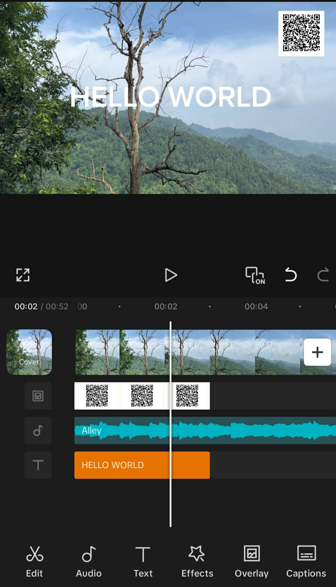
8. Result
A short BCA/AI-related video was successfully produced, combining video clips, images, text, background music, and voice narration with transitions between scenes, demonstrating the full multi-track video production workflow.
Lab No: 10 Date:
1. Title of Experiment
Edit a video by performing cut, trim, crop, transition, audio adjustment, and subtitle/title insertion, then export it in a suitable format.
2. Objective
To edit an existing video clip by cutting, trimming, cropping, applying transitions, adjusting audio, and inserting subtitles/titles, then export the final result.
3. Required Software/Hardware
- A computer running Windows / Linux / macOS
- A video editing tool (e.g. Shotcut, DaVinci Resolve, CapCut, or Windows/Clipchamp Video Editor)
- A sample raw video clip
4. Theory
Cutting/trimming removes unwanted footage from the start, end, or middle of a clip. Cropping changes the visible frame area (e.g. to remove unwanted edges or change aspect ratio). Transitions smooth the visual change between two adjacent clips/segments. Audio adjustment controls volume levels (and sometimes equalization) so narration, music, and original sound balance correctly. Subtitles/titles overlay readable text synced to specific time ranges in the video, useful for captions or on-screen labels.
5. Procedure/Algorithm
- Import the raw video clip into the video editor.
- Trim unwanted footage from the beginning and end of the clip.
- Cut out an unwanted section from the middle of the clip, if present.
- Crop the video frame if needed (e.g. to change aspect ratio or remove unwanted edges).
- Split the clip into two segments and apply a transition between them.
- Adjust the audio level of the clip (raise/lower volume as needed).
- Insert a subtitle or title text synced to a specific portion of the video.
- Export the final edited video in a suitable format (e.g. MP4).
6. Implementation/Steps
- Import the raw clip into the video editor's media bin and drag it onto the timeline.
- Drag the clip's start/end handles inward to trim unwanted footage, or use the editor's Trim tool.
- Position the playhead at the start and end of an unwanted middle section, use Split/Razor to cut it out, then delete the middle segment and close the gap ('ripple delete').
- Apply a Crop filter/effect to the clip and adjust the crop rectangle as needed.
- Split the clip at a chosen point, then drag the two resulting segments to slightly overlap and apply a transition (e.g. cross dissolve) in the overlap area.
- Select the clip's audio and adjust its Gain/Volume property up or down as needed.
- Use the Text/Title tool to add a subtitle, and set its start/end time to match the relevant portion of the video.
- Use Export/Render, choose an MP4 (H.264) preset, and save the final video file.
7. Output/Screenshot

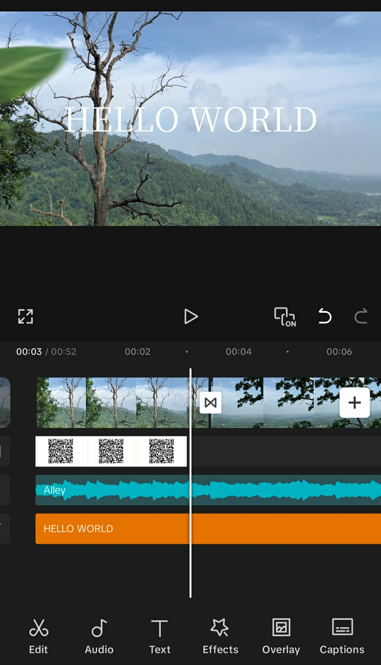
8. Result
The sample video was successfully trimmed, cut, cropped, given a transition between segments, had its audio level adjusted, and had subtitles/titles inserted, then exported as a finished MP4 file -- demonstrating the standard video-editing workflow.
Lab No: 11 Date:
1. Title of Experiment
Create a frame-by-frame animation using an animation tool. Demonstrate the use of frames, keyframes, and playback speed.
2. Objective
To create a simple frame-by-frame animation, where each frame is drawn/edited individually, and to demonstrate the effect of playback speed (frame rate) on the animation.
3. Required Software/Hardware
- A computer running Windows / Linux / macOS
- An animation tool that supports frame-by-frame drawing (e.g. Pencil2D, or a GIF-maker using a sequence of images)
4. Theory
Frame-by-frame animation is the traditional animation technique where each individual frame of the animation is drawn or created separately, and frames are played back in quick succession to create the illusion of motion (relying on the persistence-of-vision effect in human perception). A keyframe is a frame that defines an important point in the animation (e.g. a starting pose or an extreme position), while in-between frames fill the motion between keyframes. Playback speed, measured in frames per second (fps), determines how smooth or fast the resulting motion appears -- higher fps generally looks smoother but requires more individual frames.
5. Procedure/Algorithm
- Open the animation tool and create a new animation project.
- Draw/create the first frame (e.g. a ball at the leftmost position).
- Add a new frame and slightly change the drawing (e.g. move the ball slightly to the right).
- Repeat for several more frames until the object has moved across the intended path.
- Mark the important frames as keyframes.
- Set/change the playback frame rate (fps) and preview the animation at different speeds.
- Export the animation as a video or animated GIF.
6. Implementation/Steps
- Open Pencil2D (or similar) and create a new project with the desired canvas size and default frame rate (e.g. 12 fps).
- On frame 1, draw the object in its starting position.
- Add a new frame (Frame > Add Frame or similar), and redraw the object slightly moved from its previous position.
- Repeat adding frames and incrementally moving/altering the drawing until the motion sequence is complete (e.g. 10-20 frames).
- Use the Timeline panel to mark specific important frames as keyframes.
- Change the project's frame rate setting (e.g. from 12 fps to 24 fps, then to 6 fps) and use Play to preview each speed.
- Export the animation (File > Export) as an animated GIF or video file.
7. Output/Screenshot
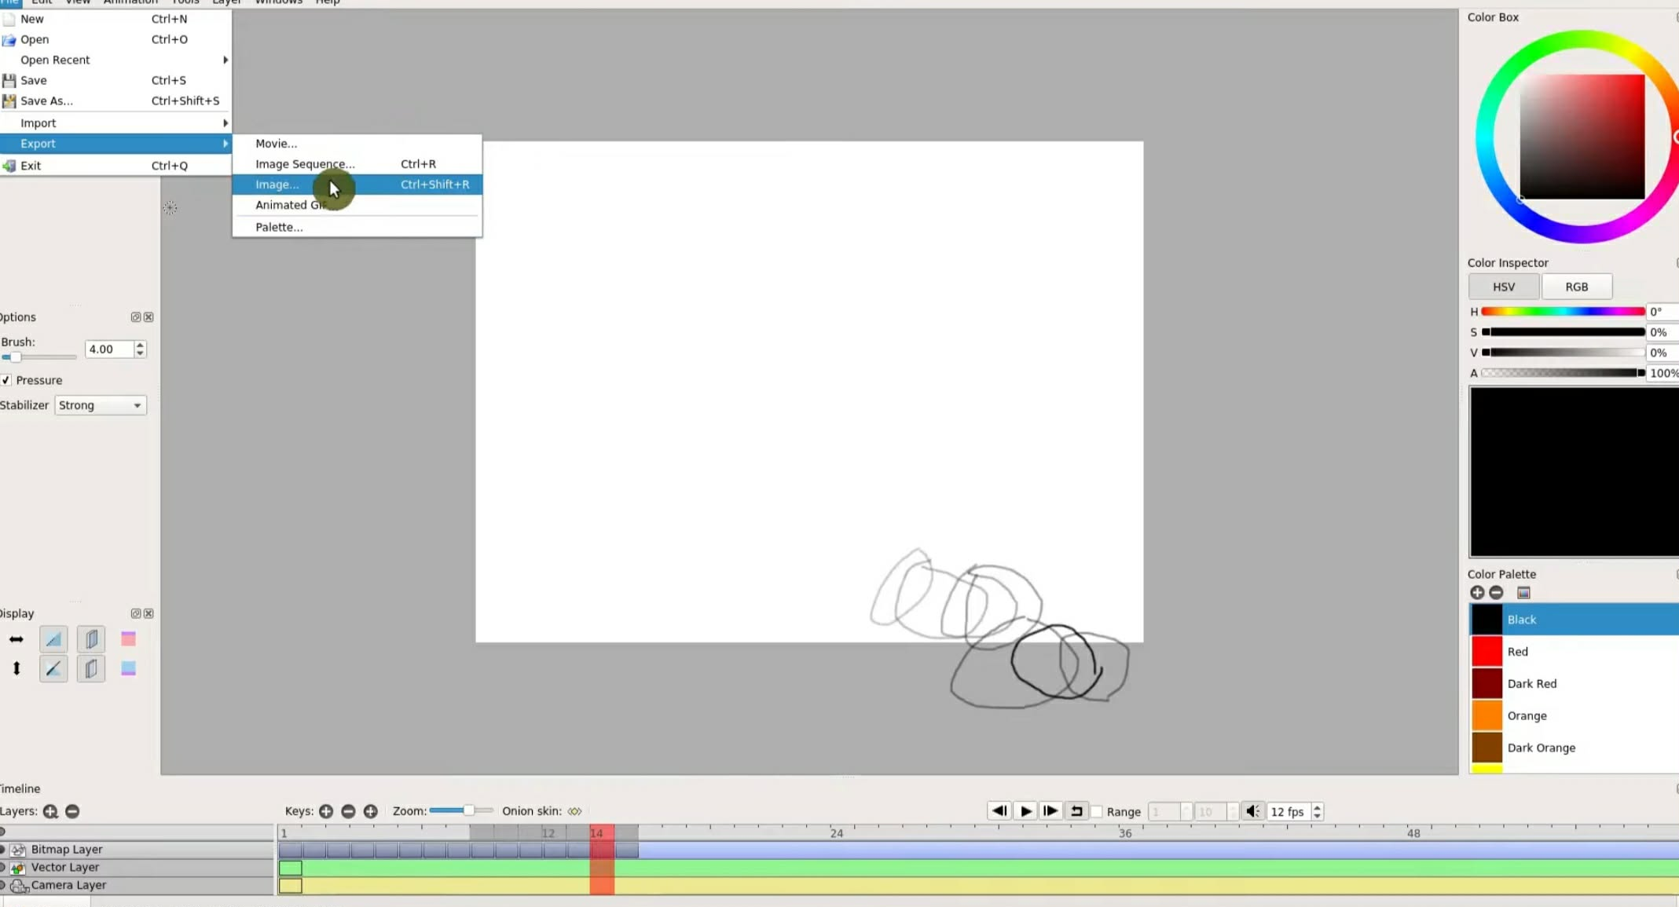
8. Result
A frame-by-frame animation of a moving object was successfully created. Increasing the playback frame rate produced smoother, more fluid motion, while a lower frame rate produced visibly choppier motion, demonstrating the direct relationship between frame rate and perceived smoothness.

Lab No: 12 Date:
1. Title of Experiment
Create a tween-based animation using keyframes. Demonstrate motion tweening and compare it with frame-by-frame animation.
2. Objective
To create a simple animation using motion tweening between two keyframes, and to compare the workflow and result with frame-by-frame animation from the previous lab.
3. Required Software/Hardware
- A computer running Windows / Linux / macOS
- An animation tool that supports tweening (e.g. Adobe Animate, Synfig Studio, or PowerPoint's Motion Path animation)
4. Theory
Tweening (short for 'in-betweening') is an animation technique where the animator only defines a starting keyframe and an ending keyframe for an object's properties (position, size, rotation, opacity), and the software automatically calculates/generates all the in-between frames through interpolation. Motion tweening specifically animates an object's position (and optionally scale/rotation) smoothly between two keyframes.
Compared to frame-by-frame animation -- where every single frame must be manually drawn -- tweening requires far less manual effort for simple movements, produces perfectly smooth interpolated motion, and results in much smaller project/file sizes, though it offers less fine-grained artistic control over each individual frame's appearance.
5. Procedure/Algorithm
- Open the animation tool and create a new project with an object (e.g. a shape or image).
- Set a starting keyframe defining the object's initial position/size.
- Set an ending keyframe defining the object's final position/size at a later point in time.
- Apply a motion tween between the two keyframes.
- Preview the animation and confirm the object moves smoothly between the two positions.
- Export the animation as a video or GIF.
- Compare the tween-based animation's process/file size/smoothness with the frame-by-frame animation from Lab 11.
6. Implementation/Steps
- In Synfig, create a new document and place an object (shape/image) on the stage.
- On the timeline, insert a keyframe at frame 1 with the object at its starting position.
- Move further along the timeline (e.g. frame 30) and insert another keyframe with the object moved to its ending position.
- Right-click the span between the two keyframes and select 'Create Motion Tween' (or the equivalent option).
- Press Play/Enter to preview -- the object should glide smoothly between the two positions.
- Export the animation (File > Export > Export Movie/Video or Export GIF).
- Note the number of manually-created frames/keyframes here versus in Lab 11, and compare final file sizes and motion smoothness.
7. Output/Screenshot
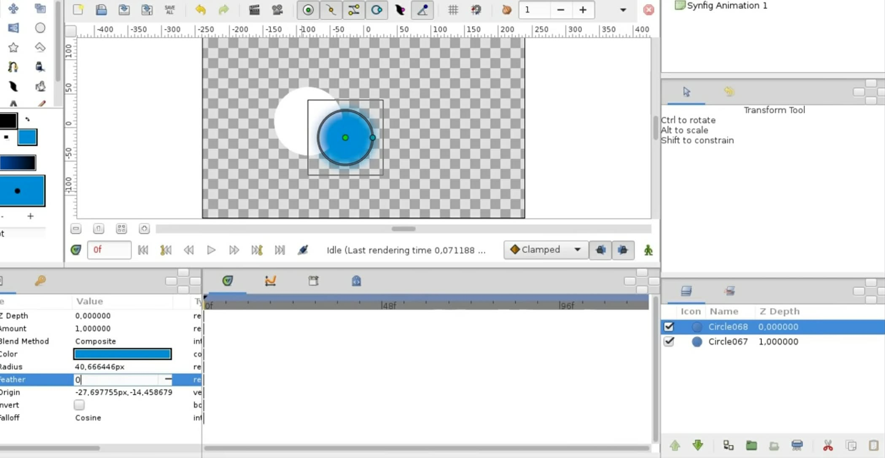
8. Result
The tween-based animation produced smooth, evenly-interpolated motion using only two keyframes, requiring far less manual effort than the frame-by-frame animation in Lab 11, though the frame-by-frame method allowed more detailed control over the object's shape changes at each point in time.

Lab No: 13 Date:
1. Title of Experiment
Implement Huffman coding for a given set of symbols and probabilities. Generate the Huffman tree and calculate the average code length and compression efficiency.
2. Objective
To implement Huffman coding for a given set of symbols and their probabilities, construct the Huffman tree, assign variable-length codes, and calculate the average code length and coding efficiency.
3. Required Software/Hardware
- A computer running Windows / Linux / macOS
- A computer with Python 3 installed
- VS Code (or any code editor) with a terminal to run the program
4. Theory
Huffman coding is a lossless entropy-based compression technique that assigns shorter binary codes to more frequent (higher-probability) symbols and longer codes to less frequent symbols, minimizing the average number of bits needed per symbol. It builds a binary tree bottom-up: the two lowest-frequency nodes are repeatedly merged into a new parent node (whose frequency is their sum) until only one root node remains; the path from the root to each leaf (0 for left, 1 for right) gives that symbol's code.
The average code length is the sum over all symbols of (probability x code length in bits). The theoretical minimum average length is given by the Shannon entropy, H = -sum(p * log2(p)). Coding efficiency is calculated as Efficiency = (Entropy / Average Code Length) x 100%, indicating how close the Huffman code gets to the theoretical best possible compression.
5. Procedure/Algorithm
- Take a set of symbols along with their probabilities as input.
- Create a leaf node for each symbol with its probability as its weight, and place all nodes in a min-priority queue.
- Repeatedly remove the two nodes with the smallest weight, combine them into a new internal node whose weight is their sum, and reinsert it into the queue.
- Continue until only a single node (the root of the Huffman tree) remains.
- Traverse the tree from the root to each leaf, assigning a '0' for each left branch and a '1' for each right branch, to obtain each symbol's binary code.
- Calculate the average code length as the probability-weighted sum of each symbol's code length.
- Calculate the Shannon entropy of the source, then compute coding efficiency as entropy divided by average code length.
6. Implementation/Steps
import heapq
import math

class Node:
def __init__(self, symbol, freq):
self.symbol = symbol
self.freq = freq
self.left = None
self.right = None

def __lt__(self, other):
return self.freq < other.freq

def build_huffman_tree(freq_table):
heap = [Node(sym, freq) for sym, freq in freq_table.items()]
heapq.heapify(heap)

while len(heap) > 1:
left = heapq.heappop(heap)
right = heapq.heappop(heap)
merged = Node(None, left.freq + right.freq)
merged.left = left
merged.right = right
heapq.heappush(heap, merged)

return heap[0]

def generate_codes(node, current_code="", codes=None):
if codes is None:
codes = {}
if node is None:
return codes
if node.symbol is not None:
codes[node.symbol] = current_code or "0"
return codes
generate_codes(node.left, current_code + "0", codes)
generate_codes(node.right, current_code + "1", codes)
return codes

# Example usage: symbols with their probabilities
symbols = {
'A': 0.4,
'B': 0.2,
'C': 0.2,
'D': 0.1,
'E': 0.1,
}

tree = build_huffman_tree(symbols)
codes = generate_codes(tree)

print("Symbol : Probability : Huffman Code")
avg_length = 0
for sym in symbols:
print(f"{sym} : {symbols[sym]:<10} : {codes[sym]}")
avg_length += symbols[sym] * len(codes[sym])

print(f"\nAverage code length: {avg_length:.3f} bits/symbol")

entropy = -sum(p * math.log2(p) for p in symbols.values())
print(f"Entropy: {entropy:.3f} bits/symbol")

efficiency = (entropy / avg_length) * 100
print(f"Coding efficiency: {efficiency:.2f}%")
7. Output/Screenshot
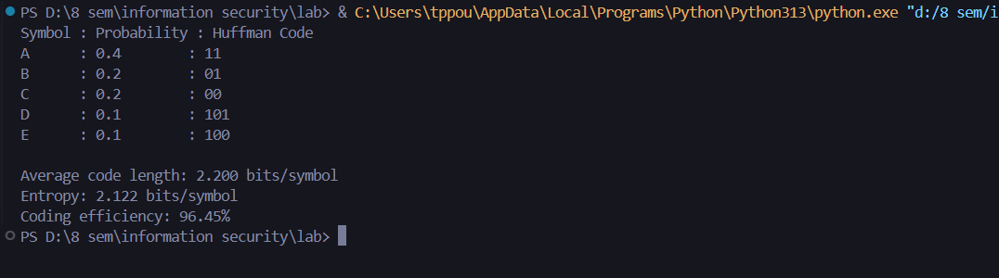
8. Result
The program successfully built a Huffman tree for the given symbol probabilities and generated variable-length codes, with more frequent symbols receiving shorter codes. The calculated average code length was close to the Shannon entropy, giving a high coding efficiency and confirming that Huffman coding is near-optimal for this symbol distribution.

Lab No: 14 Date:
1. Title of Experiment
Demonstrate JPEG/DCT-based image compression using a suitable programming language or tool. Explain the major steps involved in the compression process.
2. Objective
To demonstrate, using Python, the major steps of JPEG compression -- level shifting, the Discrete Cosine Transform (DCT), and quantization -- on a sample 8x8 pixel block, and to observe the resulting loss when the block is reconstructed.
3. Required Software/Hardware
- A computer running Windows / Linux / macOS
- A computer with Python 3, NumPy, and SciPy installed
- VS Code (or any code editor) with a terminal to run the program
4. Theory
JPEG compression works on 8x8 blocks of pixels and proceeds through several major steps: (1) Color space conversion from RGB to YCbCr and chroma subsampling (since the eye is less sensitive to color detail than brightness); (2) Level shifting, subtracting 128 from each pixel so values are centered around 0; (3) The 2D Discrete Cosine Transform (DCT), which converts the spatial pixel block into a block of frequency coefficients, concentrating most of the image's energy into a few low-frequency coefficients; (4) Quantization, dividing each DCT coefficient by a corresponding value from a quantization table and rounding, which discards the least visually important (mostly high-frequency) information -- this is the main lossy step; (5) Zig-zag reordering and entropy coding (e.g. Huffman coding) to compress the quantized coefficients into the final bitstream.
Decompression reverses these steps: entropy decoding, de-quantization (multiplying back by the quantization table), inverse DCT, and level shifting back, which reconstructs an approximation of the original block -- the small difference from the original is the 'loss' in JPEG's lossy compression.
5. Procedure/Algorithm
- Take a sample 8x8 block of grayscale pixel values.
- Apply level shifting by subtracting 128 from every pixel value.
- Apply the 2D Discrete Cosine Transform (DCT) to the level-shifted block.
- Apply a standard JPEG quantization table to the DCT coefficients, dividing and rounding each value.
- Count the number of non-zero coefficients remaining after quantization (indicating how compressible the block is).
- Reconstruct the block by de-quantizing, applying the inverse DCT, and reversing the level shift.
- Compute the Mean Squared Error (MSE) between the original and reconstructed block to quantify the loss introduced.
6. Implementation/Steps
import numpy as np
from scipy.fftpack import dct, idct

# Sample 8x8 block of pixel intensities (grayscale)
block = np.array([
[52, 55, 61, 66, 70, 61, 64, 73],
[63, 59, 55, 90, 109, 85, 69, 72],
[62, 59, 68, 113, 144, 104, 66, 73],
[63, 58, 71, 122, 154, 106, 70, 69],
[67, 61, 68, 104, 126, 88, 68, 70],
[79, 65, 60, 70, 77, 68, 58, 75],
[85, 71, 64, 59, 55, 61, 65, 83],
[87, 79, 69, 68, 65, 76, 78, 94],
], dtype=float)

# Step 1: Level shift (subtract 128)
shifted = block - 128

def dct2(a):
return dct(dct(a.T, norm='ortho').T, norm='ortho')

def idct2(a):
return idct(idct(a.T, norm='ortho').T, norm='ortho')

# Step 2: Apply 2D DCT
dct_block = dct2(shifted)

# Standard JPEG luminance quantization table
quant_table = np.array([
[16, 11, 10, 16, 24, 40, 51, 61],
[12, 12, 14, 19, 26, 58, 60, 55],
[14, 13, 16, 24, 40, 57, 69, 56],
[14, 17, 22, 29, 51, 87, 80, 62],
[18, 22, 37, 56, 68, 109, 103, 77],
[24, 35, 55, 64, 81, 104, 113, 92],
[49, 64, 78, 87, 103, 121, 120, 101],
[72, 92, 95, 98, 112, 100, 103, 99],
])

# Step 3: Quantize (divide and round)
quantized = np.round(dct_block / quant_table)

print("Quantized DCT coefficients:")
print(quantized)

nonzero = np.count_nonzero(quantized)
print(f"\nNon-zero coefficients: {nonzero} out of 64")

# Step 4: Reconstruct (dequantize + inverse DCT) to see the loss
dequantized = quantized * quant_table
reconstructed = idct2(dequantized) + 128

print("\nReconstructed block (after compression/decompression):")
print(np.round(reconstructed))

mse = np.mean((block - reconstructed) ** 2)
print(f"\nMean Squared Error vs original: {mse:.2f}")
7. Output/Screenshot
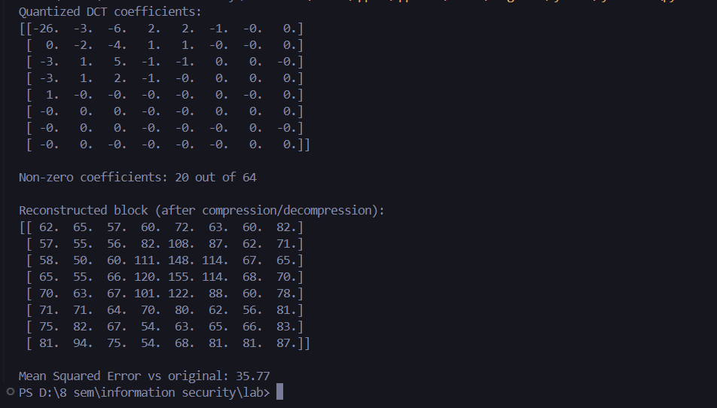
8. Result
The demonstration showed that after quantization, most of the 64 DCT coefficients became zero (concentrated energy in a few low-frequency terms), and reconstructing the block from these reduced coefficients produced a very close approximation of the original (small MSE), illustrating how JPEG achieves compression by discarding perceptually less-important frequency information.

